Assume we have a small store of products as shown in picture below, where the user can add/edit or compare the products available in the store.

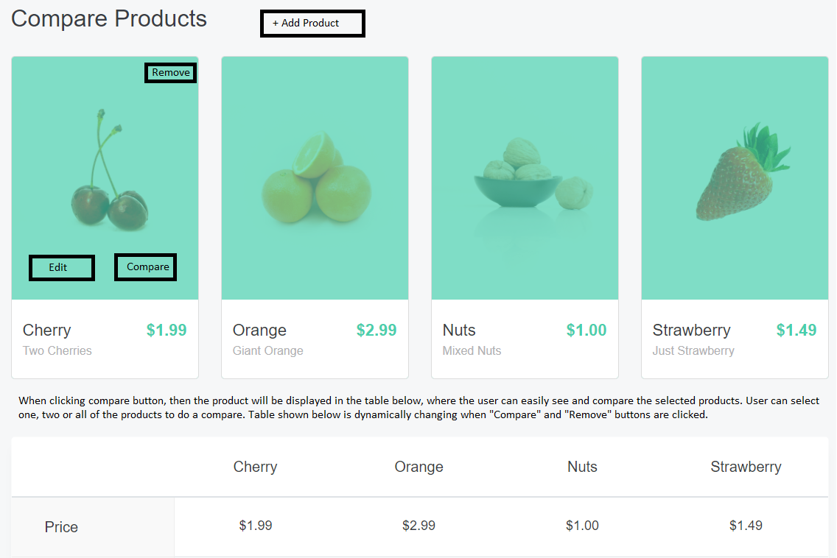

A product has the following properties:

* Name
* Price (with 2 decimals)

Using React, please design the following functionalities:

1. When accessing first the application, the page will be empty with only the button “Add Product” being visible
2. When clicking Add product button, a new popup should be loaded and displayed for the user to enter the Product Name and the price.
3. When adding a new product, please validate:
   1. The name of the product is unique (no other products share the same name)
   2. The price is higher than 0 (zero)
4. After saving a new product, we should display its name and price in a separate tile (as displayed in the image)
5. Clicking on “Edit” button, will present to the user the edit popup (can be the same popup used for Adding new product). The user should be able to rename or change the price of the product.
6. Below the tiles that are displaying the products, a comparison table should be displayed with all the products that were selected for compare using “Compare” button functionality.
7. Whenever a product is selected to be compared, it should be displayed in the comparison table and the “Remove” button should be displayed on the tile of the product. And the “Compare” button shouldn’t be visible anymore for that product in its tile.
8. If the user clicks “Remove” button, then the product will be dynamically removed from the comparison table. After a product was removed from the table, “Remove” button should be automatically hidden from the Product tile and “Compare” button should be visible again for new comparisons.
9. Products images are optional, not mandatory.

Please send us your zip archive containing your code files along with any other asset files required to build and run the application. Application should compile using npm command lines.